POS application running, on one half it will be line up items typical POS application, on the other half it will be the web browser vertically, showing a carousel of images which will change with time but will not be changeable by the cashier.
Agregar mediante HTML un carousel de imágenes, de forma vertical. Cada X segundos se va cambiando, luego hay que usar las imágenes que estén subidas en file cabinet.
Podemos obtener un link descargable desde file cabinet que es accesible para usar estas imágenes.
For the file of the ads:
On NSPOS launch, check a file cabinet hash to see if the files have changed.
- If YES:
  - Delete the current My Pictures directory
  - Download the new folder locally to My Pictures
- If NO:
  - Do not download anything new
- Launch the Browser from NSPOS
There's an "on startup" folder that any scripting there will run before NSPOS fully launches. There we add our script to download all the images to local folder.

The above check is just to keep from having to stream down the images every time they change and was something I discussed with Mike. That way, if they have 100 registers doing this they don't have to download the images 100 times every 5 seconds.
We would use the NetSuite File Cabinet for this. We may be able to set the folder dynamically based on a POS setting, so for instance the Mets Arena would have different ads than the T-Mobile Arena, etc
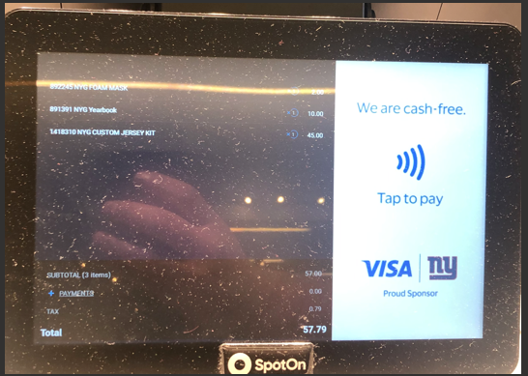

Va a ser en localhost
Tendrán 10 inches de ventana

Some assumptions
- All screen sizes per each WORKSTATION GROUP would need to be the same. That is due to the scripting that creates the second monitor display for NSPOS and is not something we can change.
- On account of any failure, for instance, if the internet is down, NSPOS would just use the currently cached ads, and upon Application, the restart would do the normal check again.
August 1st
September 1st done date.

Questions
  - On NSPOS launch, check a file cabinet hash to see if the files have changed.
    - If YES:
      - Delete the current My Pictures directory
      - Download the new folder locally to My Pictures
    - If NO:
      - Do not download anything new
    - Launch the Browser from NSPOS
Where do we download the new folder locally? When NSPOS launches but how do we trigger that?

Steps
Instalar xampp:
https://www.youtube.com/watch?v=IJGxS9A0dTw

Creo ahí en esa carpeta htdocs un archivo html, al que le voy a asociar un archivo js y un archivo css que los voy a acceder.
Luego, miro Bootstrap, y lo integro a mi proyecto:
https://getbootstrap.com/docs/4.0/getting-started/introduction/
Uso el template que dice ahí, luego trato de integrar la componente de carousel:
https://getbootstrap.com/docs/4.0/components/carousel/

